Date access: 2020-03-10

<http://wjw.beijing.gov.cn/wjwh/ztzl/xxgzbd/gzbdyqtb/202002/t20200202_1622645.html>

From 12:00 to 24:00 on February 1st, 15 new cases of pneumonia infected with new coronavirus were added to the city

Date: 2020-02-02 Source: Beijing Municipal Commission of Health

        From 12:00 to 24:00 on February 1, 15 new pneumonia cases of new coronavirus infection were reported in the city, 11 cases had contact history in Hubei and other provinces, 4 were close contacts of confirmed cases, 2 of which had Hubei And contact history in other provinces are close contacts of confirmed cases. Two cases denied contact history in Hubei, and are being further verified. All have been sent to designated medical institutions for treatment.

As of 24:00 on February 1, a total of 183 confirmed cases were found in this city, of which 1 died, 9 were discharged, and 173 were treated in isolation at designated hospitals. 3 cases in Dongcheng District, 17 cases in Xicheng District, 35 cases in Chaoyang District, 41 cases in Haidian District, 16 cases in Fengtai District, 4 cases in Shijingshan District, 1 case in Mentougou District, 2 cases in Fangshan District, 13 cases in Tongzhou District, 6 cases in Shunyi District, There were 12 cases in Changping District, 21 cases in Daxing District, 1 case in Huairou District, and 11 cases came from overseas. No cases have been reported in Pinggu District, Miyun District and Yanqing District.

**2月1日12时至24时，本市新增15例新型冠状病毒感染的肺炎病例**

日期：2020-02-02 来源：北京市卫生健康委‍

        2月1日12时至24时，本市新增15例新型冠状病毒感染的肺炎病例，11例有湖北及其他省份接触史，4例为确诊病例的密切接触者，其中2例既有湖北及其他省份接触史又是确诊病例的密切接触者。2例否认湖北接触史，正在进一步核实。均已送至定点医疗机构进行救治。

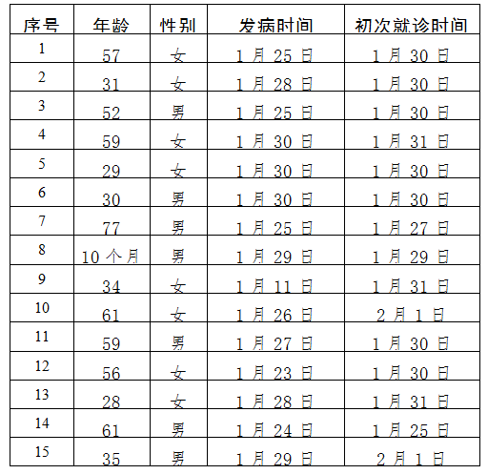

        截至2月1日24时，本市累计确诊病例183例，其中死亡1例，出院9例，173例在定点医院进行隔离治疗。东城区3例、西城区17例、朝阳区35例、海淀区41例、丰台区16例、石景山区4例、门头沟区1例、房山区2例、通州区13例、顺义区6例、昌平区12例、大兴区21例、怀柔区1例、外地来京人员11例。平谷区、密云区、延庆区尚未有病例。